**4) API Automation:**

Below is a GET API to fetch upcoming movies in Paytm.

https://apiproxy.paytm.com/v2/movies/upcoming

Sampler Result :- with 200 ok response

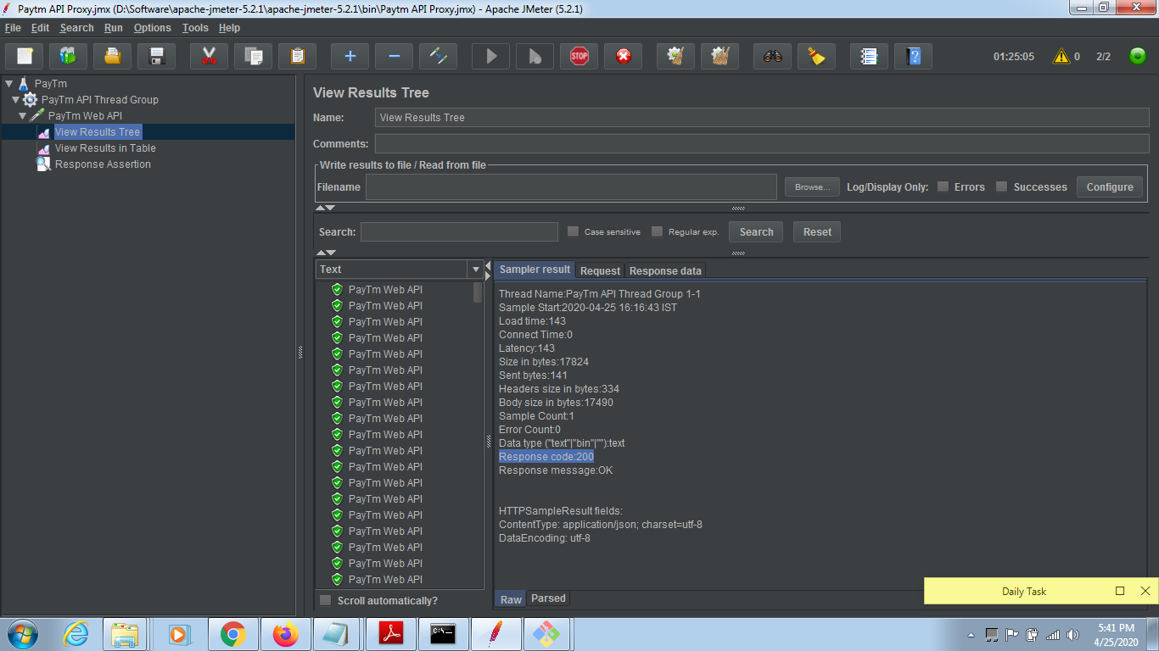

2- View Result Tree in Request (Request Headers) :-

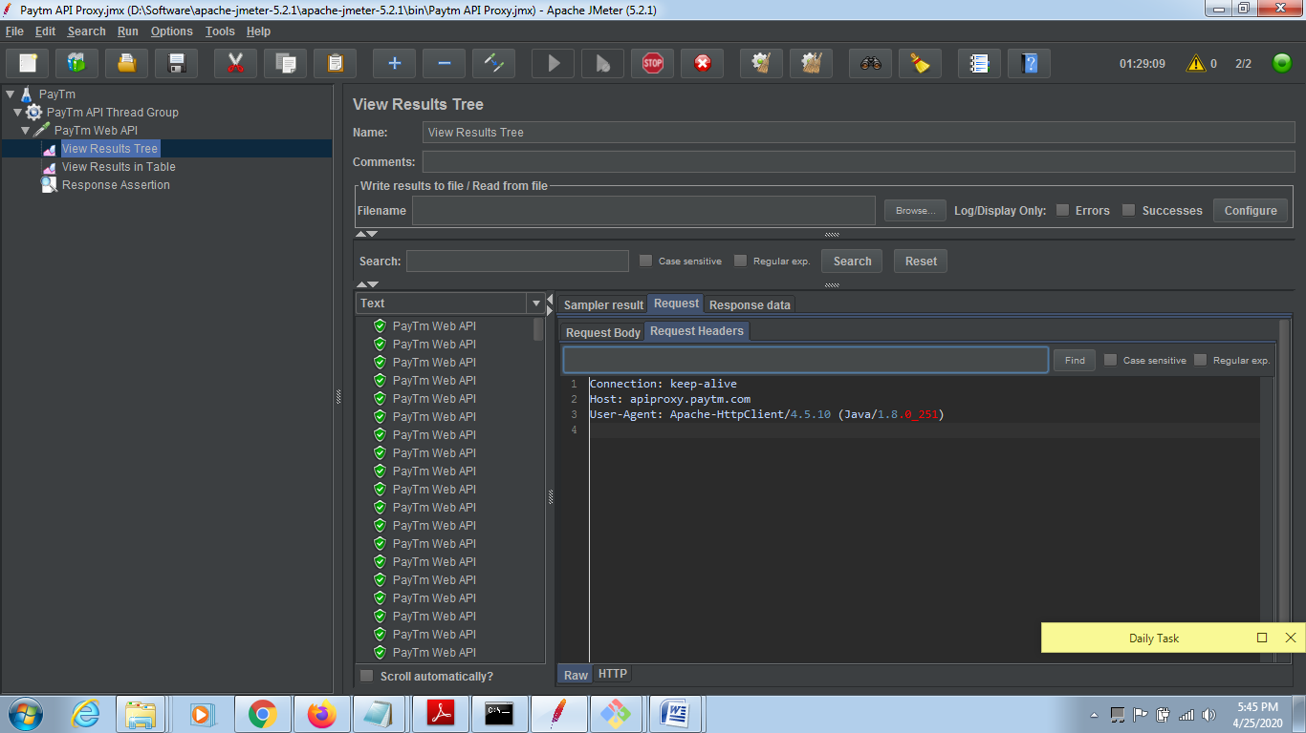

3- View Result Tree with Response Data

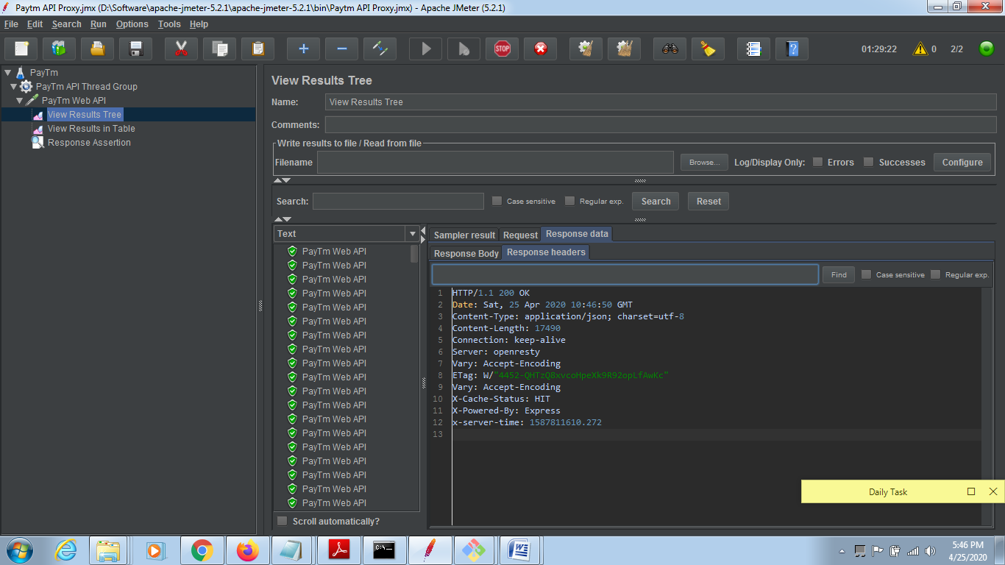

4- View Result in Table

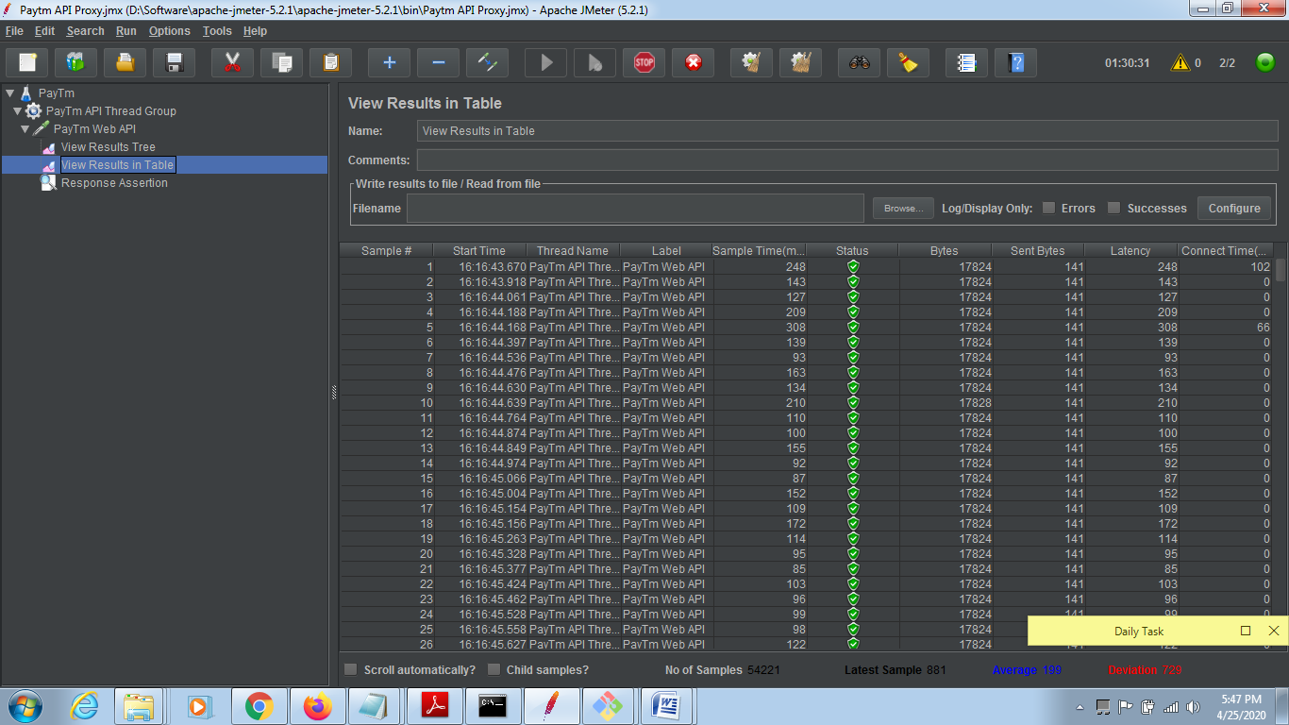

Paytm Movie code :-

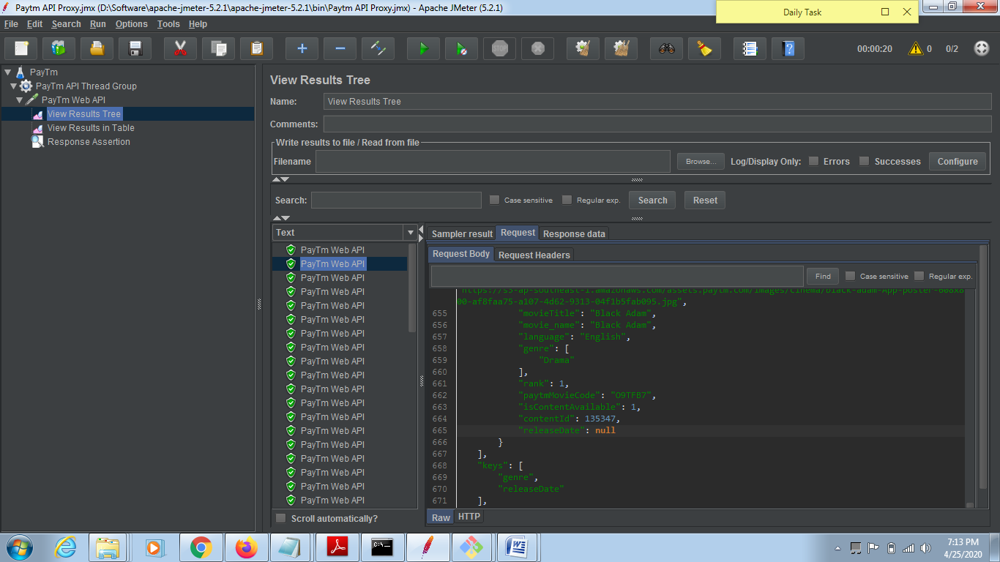

Paytm Movie code individual :-

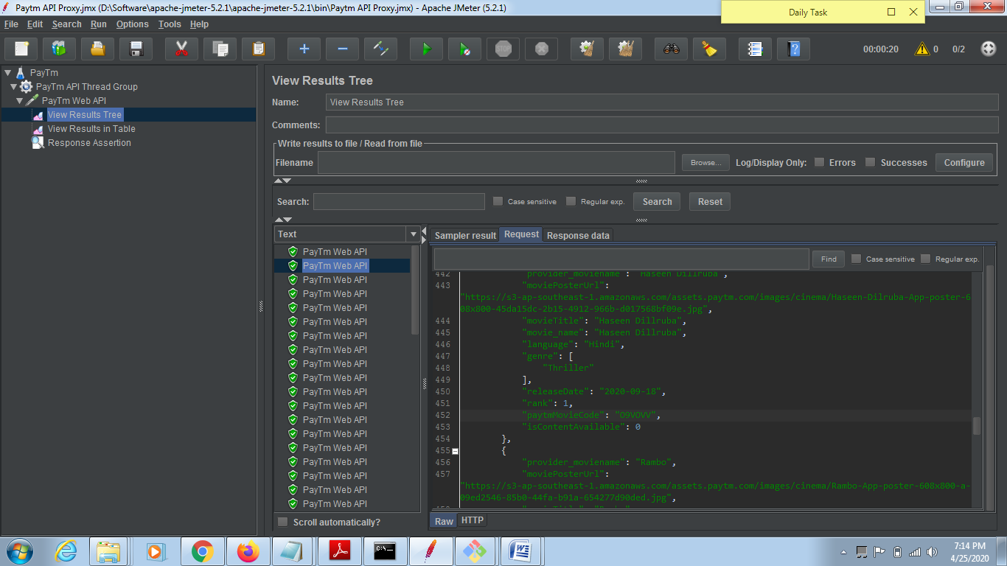

Movie Release Date : Is not before today date

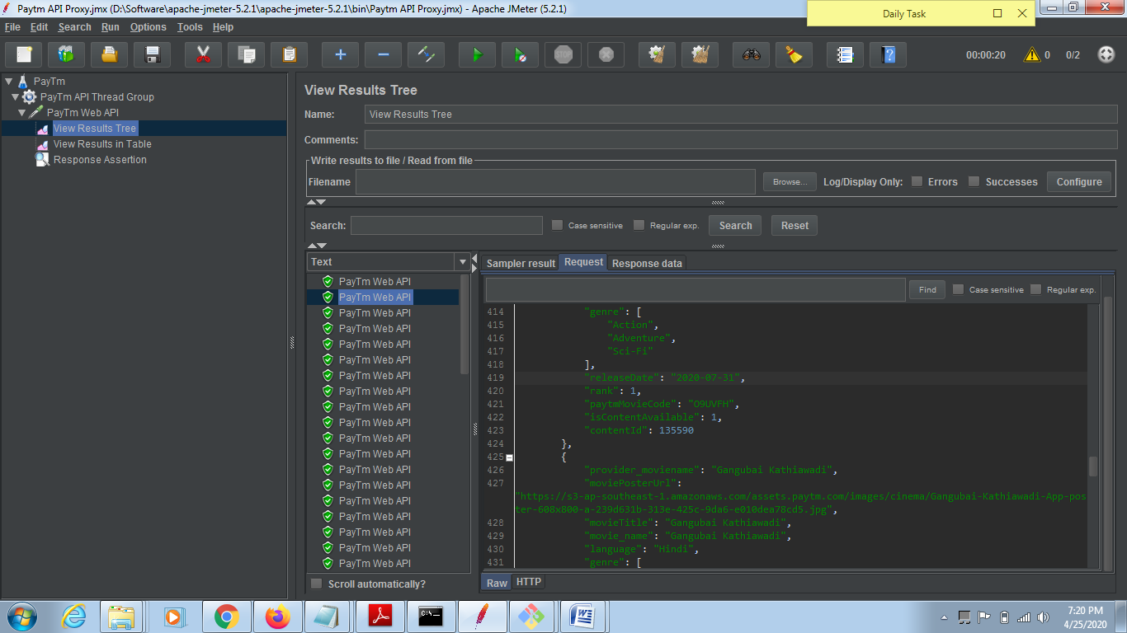

Movie Poster URL : Is in .JPG format

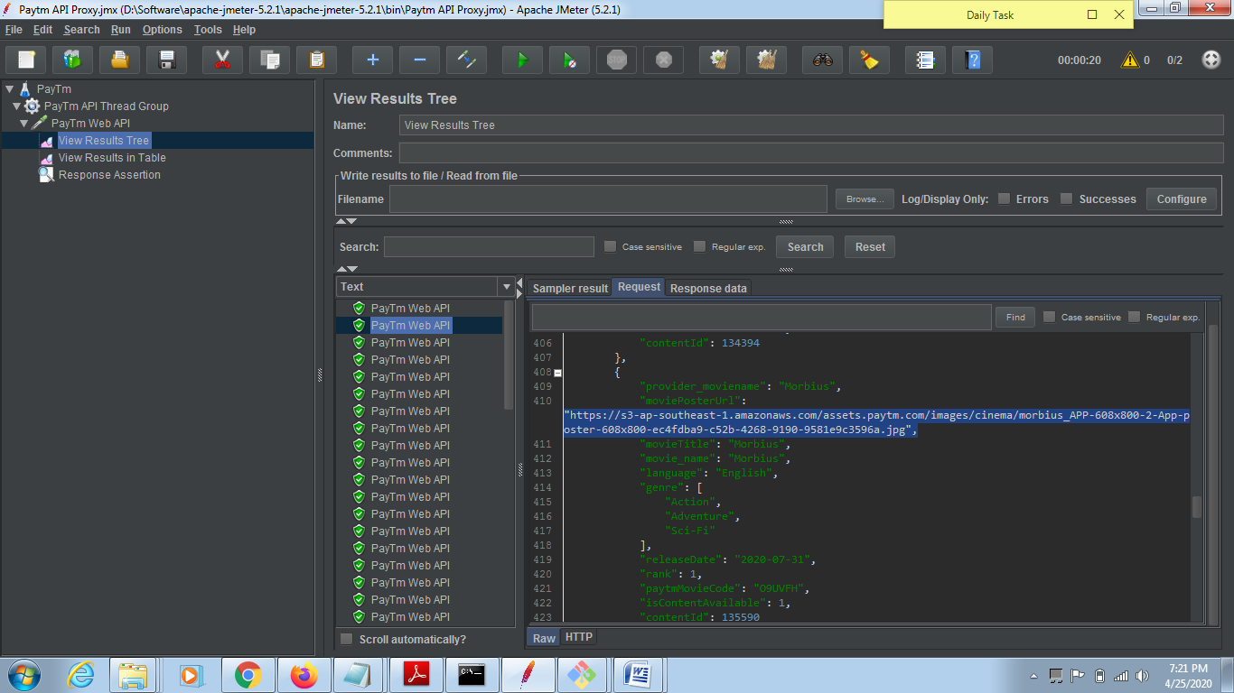

Paytm Movide code is Unique :-

